Problem 5.0

Code:

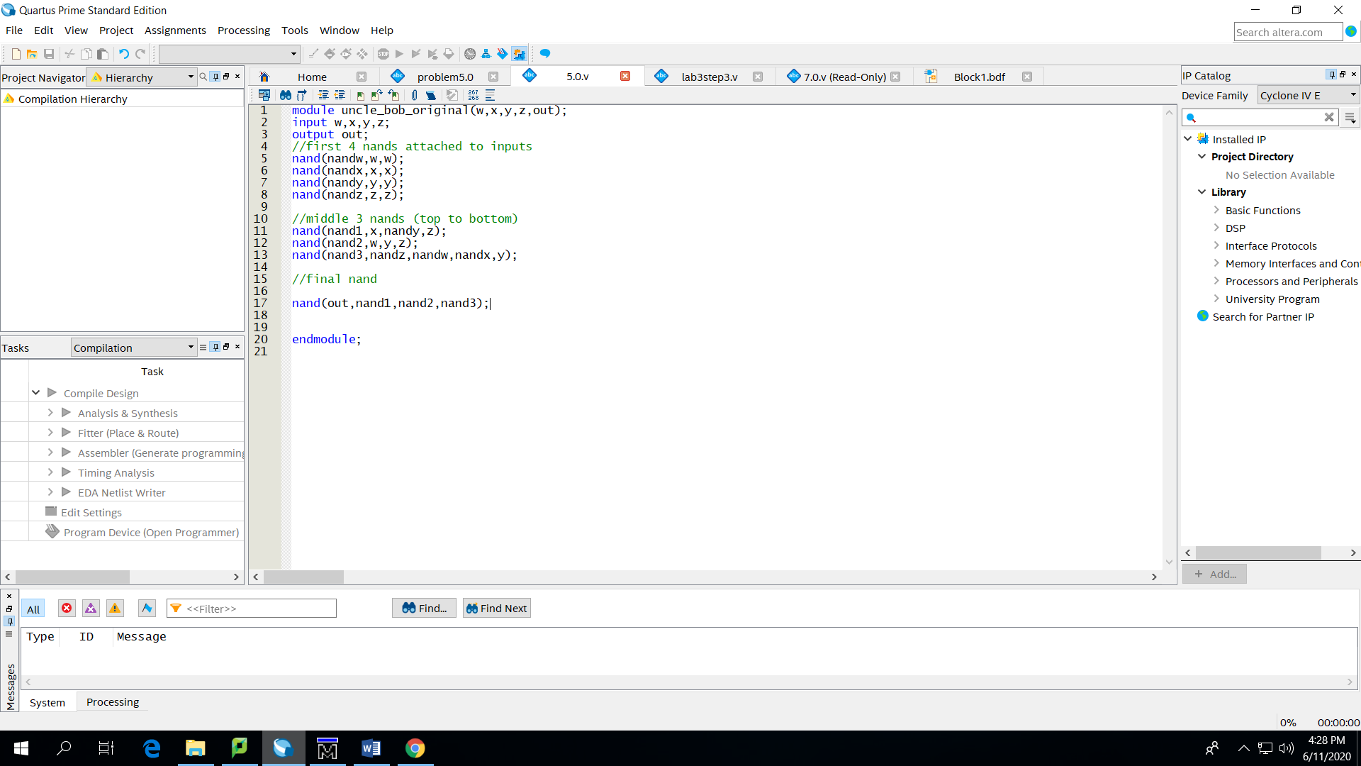

Results(w,x,y,z):

|  |
| --- |
| 0000 |
| 0001 |
| 0010 |
| 0100 |
| 1000 |
| 0011 |
| 0110 |
| 1100 |
| 1010 |
| 0101 |
| 1001 |
| 1110 |
| 1011 |
| 1101 |
| 0111 |
| 1111 |

7.0

Code:

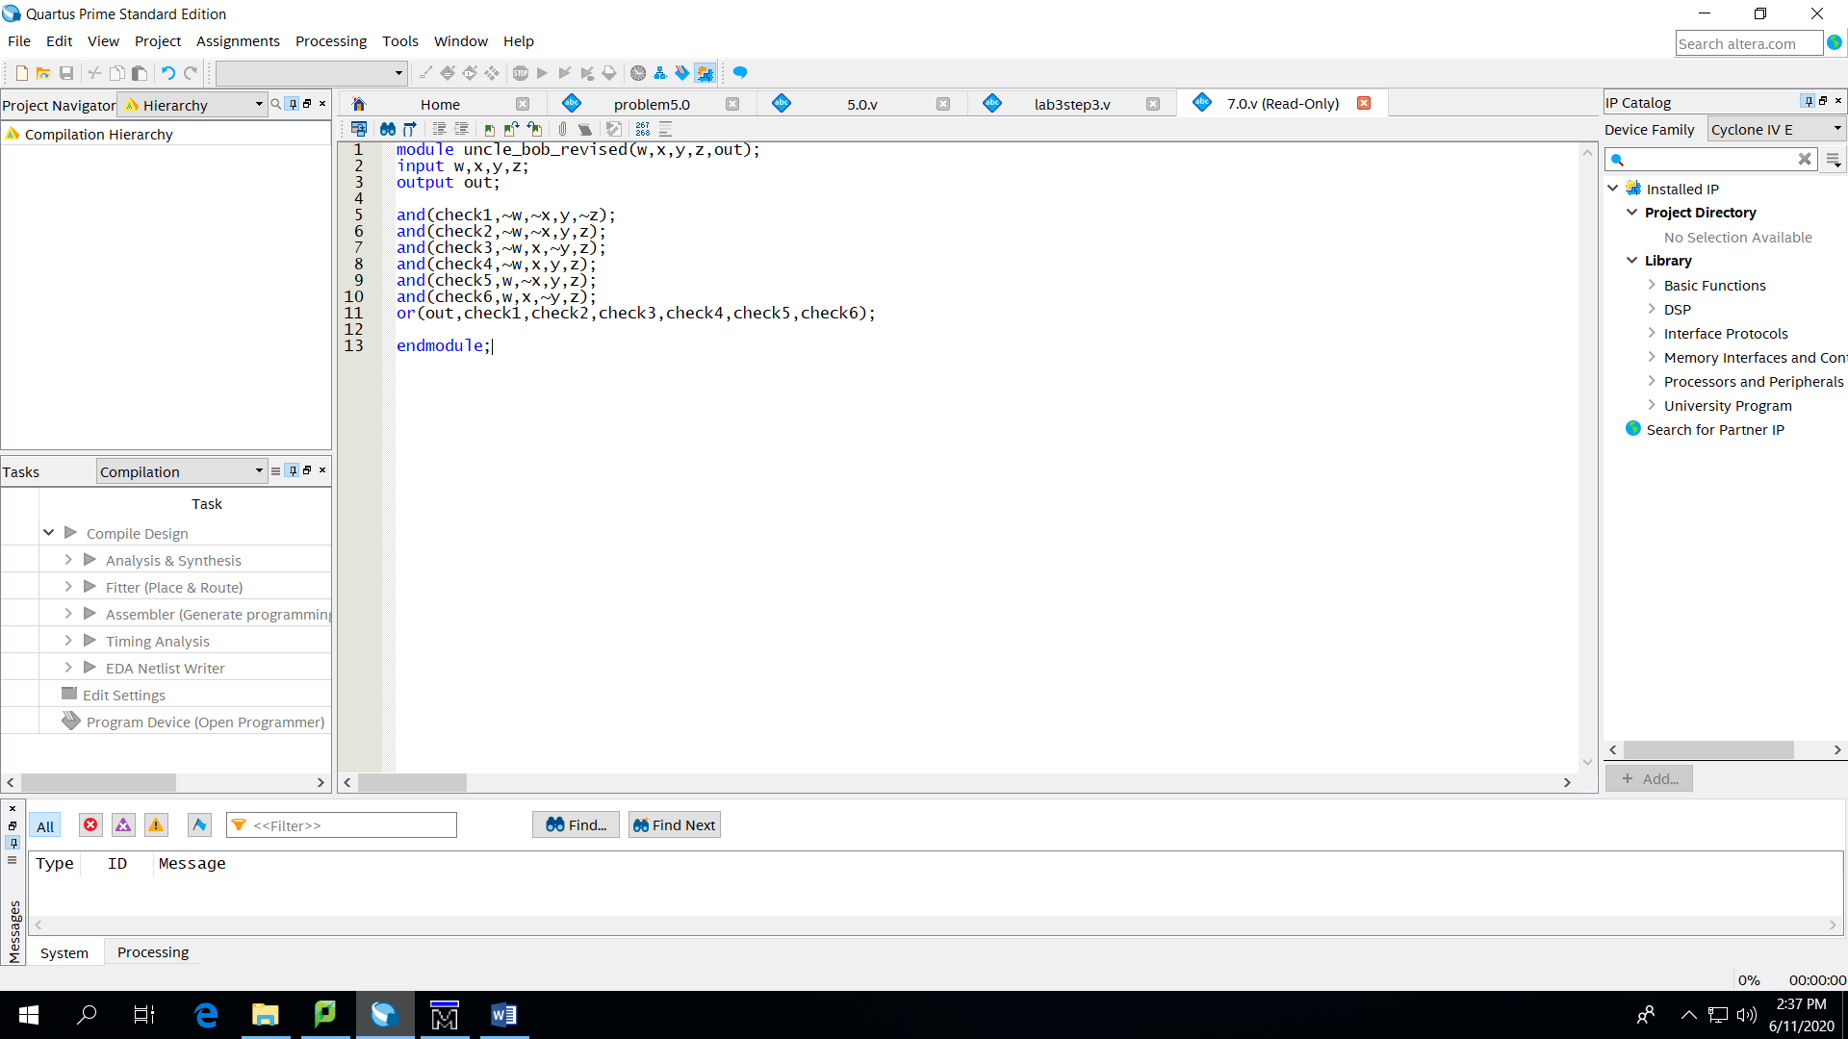

Results(w,x,y,z):

|  |
| --- |
| 0000 |
| 0001 |
| 0010 |
| 0100 |
| 1000 |
| 0011 |
| 0110 |
| 1100 |
| 1001 |
| 1010 |
| 0101 |
| 1110 |
| 0111 |
| 1101 |
| 1011 |
| 1111 |

8.0

Diagram:

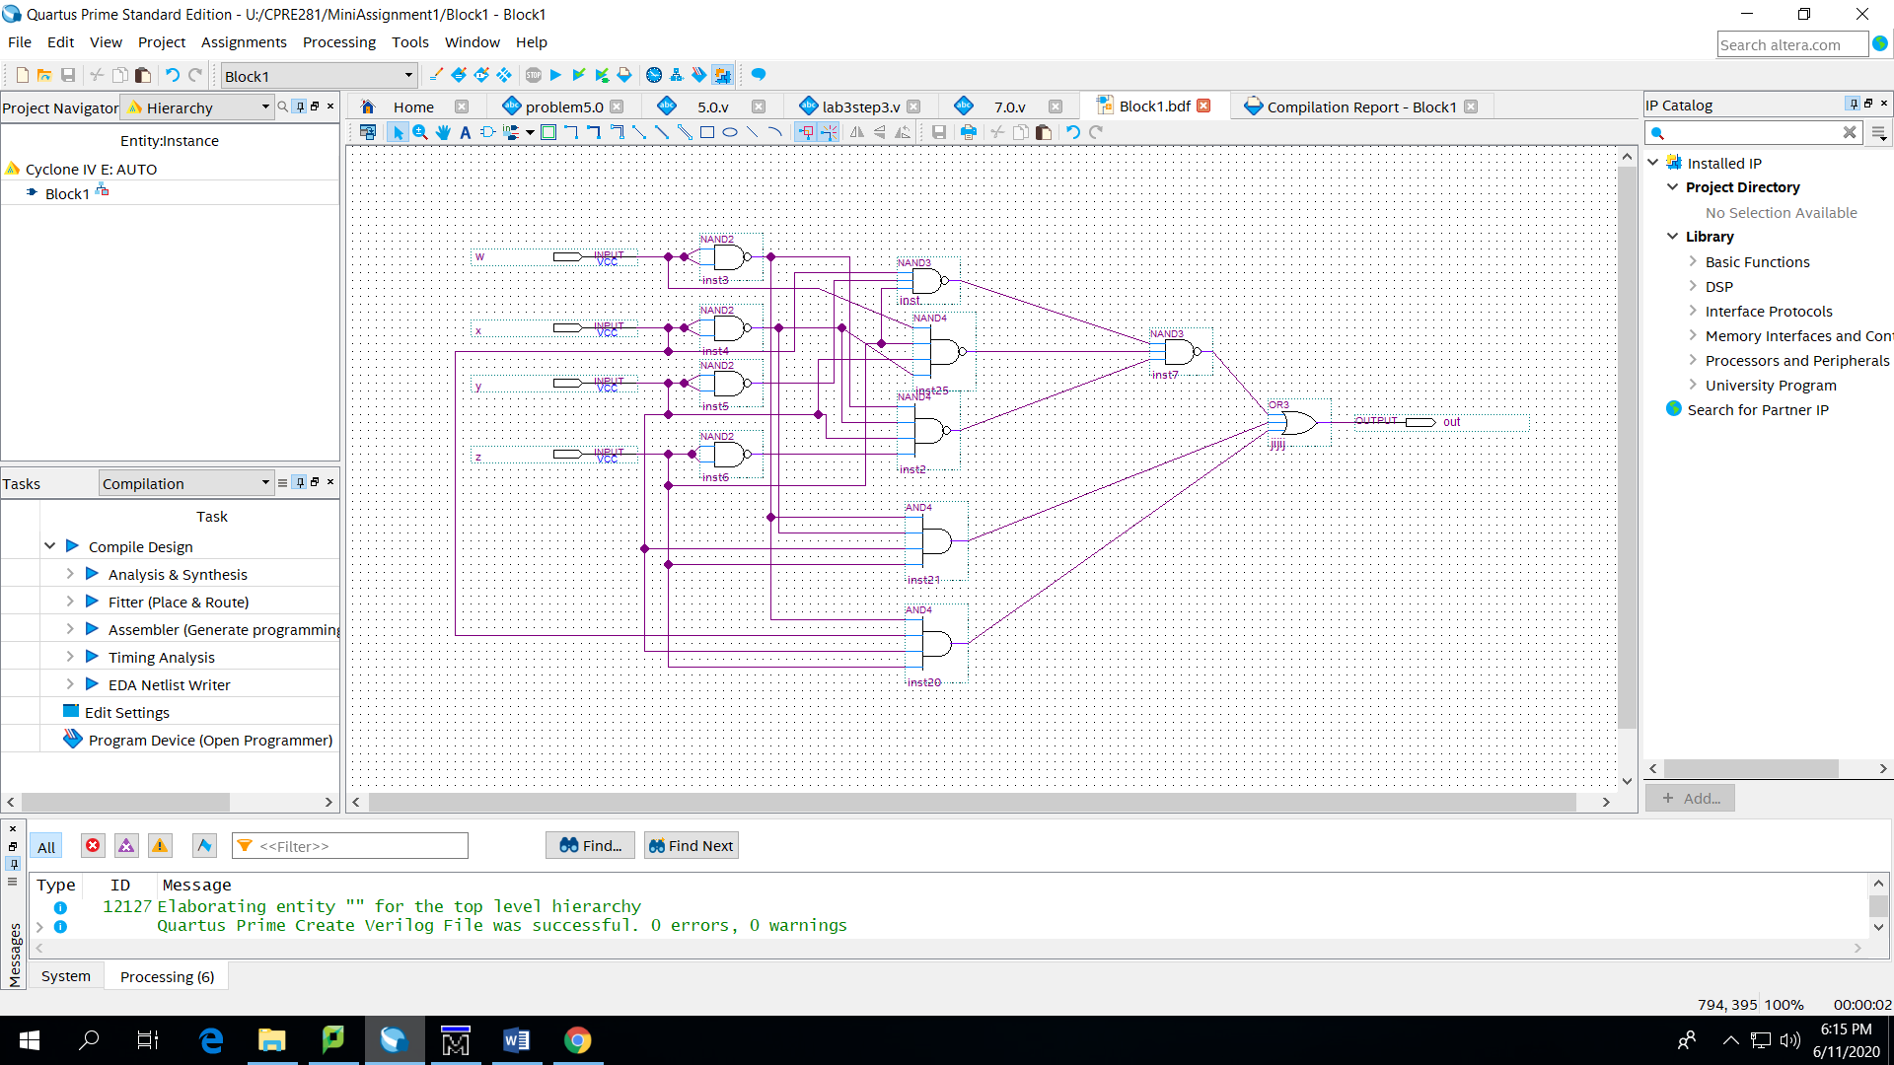

Results(wxyz):

|  |
| --- |
| 0000 |
| 0001 |
| 0010 |
| 0011 |
| 0100 |
| 0101 |
| 0110 |
| 0111 |
| 1000 |
| 1001 |
| 1010 |
| 1011 |
| 1100 |
| 1101 |
| 1110 |
| 1111 |